Given strings s1, s2, and s3, find whether s3 is formed by an **interleaving** of s1 and s2.

An **interleaving** of two strings s and t is a configuration where they are divided into **non-empty** substrings such that:

* s = s1 + s2 + ... + sn
* t = t1 + t2 + ... + tm
* |n - m| <= 1
* The **interleaving** is s1 + t1 + s2 + t2 + s3 + t3 + ... or t1 + s1 + t2 + s2 + t3 + s3 + ...

**Note:** a + b is the concatenation of strings a and b.

**Example 1:**

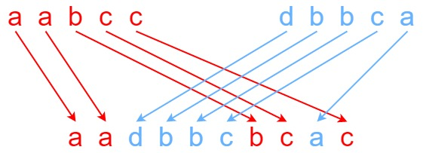

**Input:** s1 = "aabcc", s2 = "dbbca", s3 = "aadbbcbcac"

**Output:** true

**Example 2:**

**Input:** s1 = "aabcc", s2 = "dbbca", s3 = "aadbbbaccc"

**Output:** false

**Example 3:**

**Input:** s1 = "", s2 = "", s3 = ""

**Output:** true

**Constraints:**

* 0 <= s1.length, s2.length <= 100
* 0 <= s3.length <= 200
* s1, s2, and s3 consist of lowercase English letters.